**Assignment 2:** Neural Network

Learning rate vs hidden layer testing accuracy and training accuracy

|  |  |  |  |  |  |  |
| --- | --- | --- | --- | --- | --- | --- |
|  | Exp 1 | | Exp 2 | | Exp 3 | |
| LR | 0.0001 | | 0.001 | | 0.01 | |
|  | Train | test | train | test | train | test |
| H_2 | 0.7945 | 0.8035 | 0.80325 | 0.8055 | 0.811 | 0.816 |
| H_4 | 0.79725 | 0.8055 | 0.7945 | 0.8035 | 0.7945 | 0.8035 |
| H_6 | 0.7945 | 0.8035 | 0.794625 | 0.8035 | 0.7945 | 0.8035 |
| H-8 | 0.7945 | 0.8035 | 0.7945 | 0.8035 | 0.816125 | 0.8175 |
| H-10 | 0.81625 | 0.8165 | 0.80775 | 0.819 | 0.8135 | 0.821 |
| H-12 | 0.81162 | 0.8215 | 0.802 | 0.8115 | 0.7945 | 0.8035 |
| H-14 | 0.815875 | 0.8165 | 0.806625 | 0.816 | 0.7945 | 0.8035 |
| H-16 | 0.800 | 0.8095 | 0.810125 | 0.82 | 0.814875 | 0.818 |
| H-18 | 0.7978 | 0.808 | 0.8155 | 0.8175 | 0.799 | 0.8095 |
| H-20 | 0.814125 | 0.821 | 0.80025 | 0.81 | 0.81775 | 0.821 |

Exp : 1 Exp : 2 Exp : 3

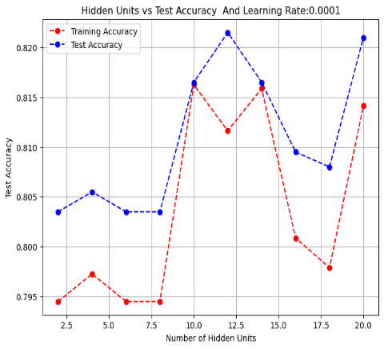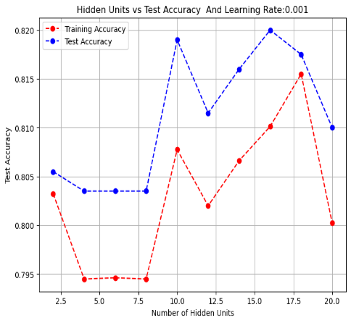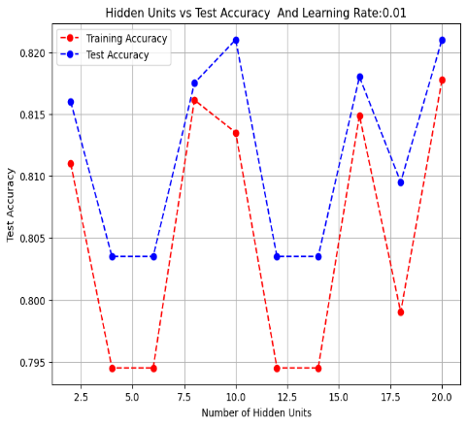

The results show that a higher learning rate (0.01) achieves the best testing accuracy (0.821) with 10 and 20 hidden layers, indicating improved performance with deeper networks. A moderate learning rate (0.001) also performs well, reaching close to peak accuracy (0.82) with 16 hidden layers, offering a balance between training stability and accuracy. Overall, increasing the learning rate with a sufficiently deep model yields better generalization.